**sklearn** to build a machine learning model using the k-Nearest Neighbors algorithm to predict whether the patients in the "Pima Indians Diabetes Dataset" have diabetes or not.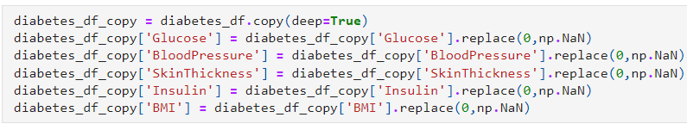

For HeadMAP -> Interpretation: No significant case of multicollinearity is observed.

KNN classifier predicts the class of a given test observation by identifying the observations that are nearest to it.

KNN requires us to find some optimal k value

Note: You can also plot the error on the y-axis, which is quite common as well.

***Note: You should also take into account cross-validation when considering different models. A separate exercise however will be created covering different cross-validation techniques.***